**Requirement**

1. **Trucks List** 
   1. Zone List
   2. State List
   3. Move truck from zone state to other zone state
2. **Credit Check (?)**

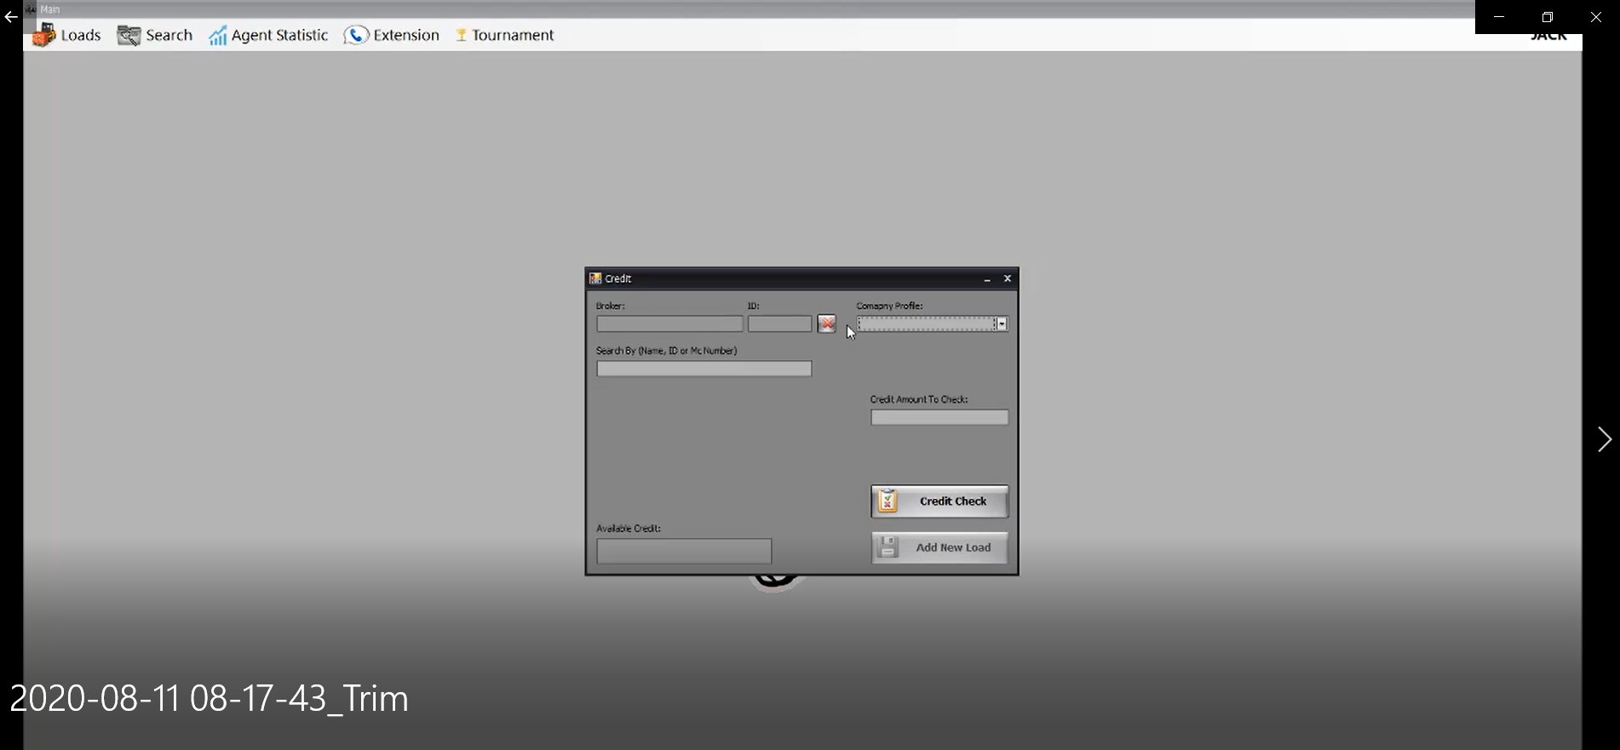

1. **Agent in Charges of load (?)**

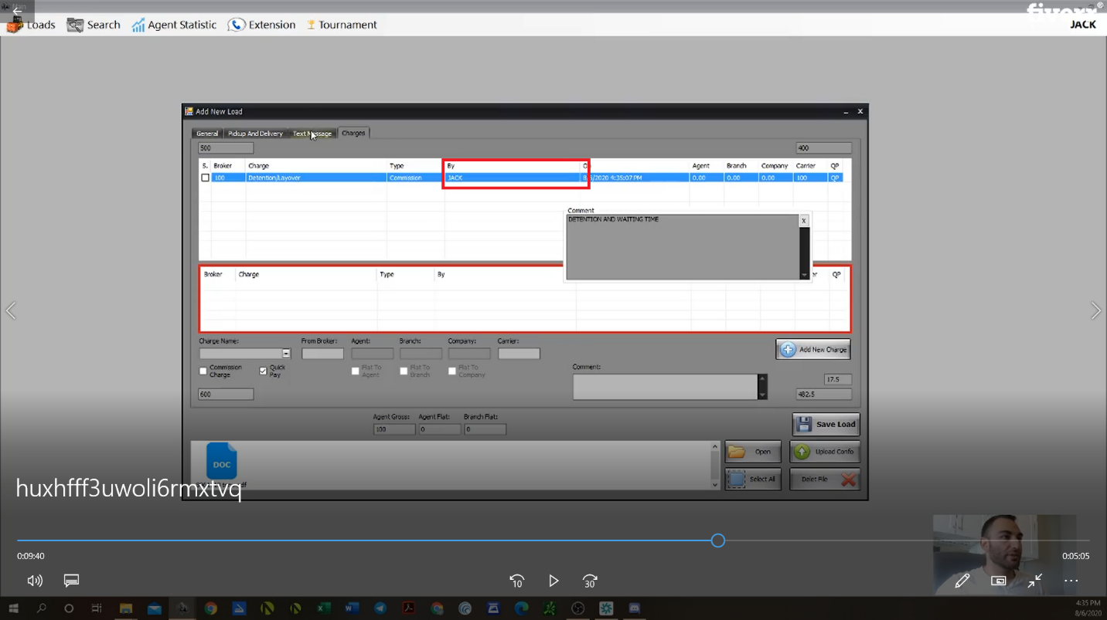

1. **Load Confirmation**

